“And the peace of God, which surpasses all comprehension, will guard your hearts and your minds in Christ Jesus.” -- Philippians 4:7
- Please show all your work! No partial credit will be given for incorrect answers with no work shown. Please draw a box around your final answer.
- Calculators are permitted, but no notes, text, laptops, PDAs, or electronic dictionaries.
- Cell phones should be muted and left in your pocket or bag.
Total marks: 110

- 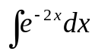
(-1/2) e^{-2x}
- 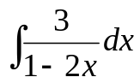
(-3/2) ln(1-2x)
- 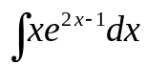
(x/2 - ¼) e^{2x-1}
- 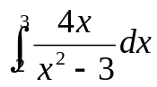
2ln6
- 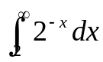
1 / (4ln2)
- Find the area between the curves y=10 – 2x – x² and y = x.

- Find dz/dx if 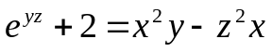.

- Consider 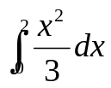.

  - Solve the integral exactly.
8/9
  - Approximate the integral using Simpson’s rule with Δx=0.5.

- Solve: 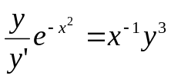
( (-3/2)e^{-x^2} + C )^{1/3}
- (Sorry, I’m still working on coming up with new questions! For now, use the two midterms, their corresponding practise midterms, and the homework for practise.)
- 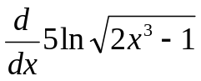 [3]
15x² / (2x³ – 1)
- 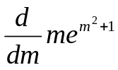 [3]
e^{m^2+1} + 2m²e^{m^2+1}
- 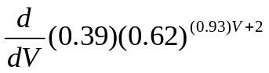 [3]
(0.39) (0.93) ln(0.62) (0.62)^{(0.93)V + 2}
- 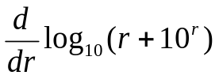 [4]
[ 1/ln(10) ] * [ 1/(r + 10^{r}) ] *
[ 1 + ln(10)10^{r} ]
- 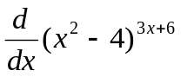 [4]
(x²-4)^{3x+6} [ 3ln(x²-4) + 6x/(x-2) ]
- Find dy/dx if: y e^{x} = x e^{y} [3]
( e^{y} – y e^{x} ) / ( e^{x} – x e^{y} )
- Let 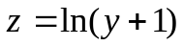, 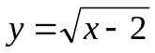, and 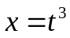. Find dz/dt when t=3. [4]
9/20
- 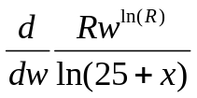 [3]
ln(R) R w^{ln(R)-1} / ln(25+x)
- Find dy/dx if x = y^{y}. [4]
1 / [ x ( ln(y) + 1 ) ]
- Find d²y/dx² if 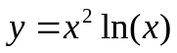. [3]
2ln(x) + 3

- Find the equation of the line tangent to the curve 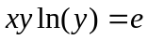 at the point (1, e). [4]
-e/2
- The demand equation for a product is 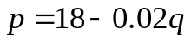.
  - What is the price when q=600 units are demanded? [1]
p = $4.00
  - Find the point elasticity of demand when q=600. Is the demand elastic? [4]
1/3: inelastic
- The height (in feet)of a ball thrown in the air is 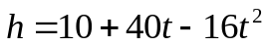, t seconds after it has been thrown.
  - When is the velocity zero? Interpret this in the context of the ball’s trajectory. [3]
t=1.25 seconds: the apex/top/vertex of the ball’s trajectory
  - What is the acceleration on the ball (due to gravity)? What are its units? [2]
-32 ft/s².
- Use Newton’s method to approximate 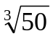 (hint: it is the root of 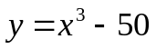). Start with an initial guess of x₀ = 4 and show two steps (find x₁, x₂). [6]
f’(x) = 3x²
x₁ = x₀ – f(x₀)/f’(x₀)
= 4 – f(4)/f’(4)
= 4 – 14/48
≈ 3.708333
x₂ = 3.708333 – f(3.708333) / f’(3.708333)
≈ 3.684190
- Consider the function 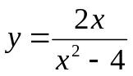.
  - Find all x and y intercepts. [2]
(0,0)
  - Find all vertical asymptotes. [2]
x = -2, +2
  - Find all horizontal asymptotes. [2]
y = 0
  - Find all zeroes and discontinuities of the function. [2]
x = 0, -2, +2
  - On what intervals is the function positive? Negative? [3]
(-∞, -2): +. (-2, 0): +. (0, 2): –. (2, ∞): +
  - Find all critical points. [3]
x = -2, +2
  - On what intervals is the function is increasing? Decreasing? [3]
Decreasing everywhere.
  - Sketch the curve. [2]

